**CHAPTER 1**

**INTRODUCTION**

In today’s rapidly urbanizing world, the demand for smart solutions to everyday challenges has increased significantly. Parking management, especially in urban areas, has become a pressing issue due to the surge in vehicle numbers, coupled with limited space availability. Drivers frequently struggle to locate vacant parking spots, leading to wasted time, increased frustration, higher fuel consumption, and elevated levels of emissions. These challenges underscore the need for efficient, real-time parking management solutions that can offer an organized and sustainable approach.

Our project, an IoT-Based Car Parking System, addresses these challenges by combining hardware and software components to create a comprehensive solution. This system leverages the Internet of Things (IoT), a technological approach that enables devices to communicate and share data in real-time, thereby optimizing processes that were previously handled manually. The IoT-based parking system we aim to develop will detect parking slot availability through ultrasonic sensors, control entry and exit via servo motors, and enable remote monitoring through an MQTT dashboard. The system provides real-time updates on parking space availability to users, offering a seamless and automated experience from the moment a vehicle approaches the parking entrance to when it exits.

The project is motivated by the need to reduce the time drivers spend in finding parking, alleviate traffic congestion, and lower fuel consumption and emissions. Traditional parking systems require drivers to check each slot manually, which is inefficient and can often result in occupied spaces being mistaken for free ones, leading to further frustration. By automating the process and providing real-time data on the dashboard, our system solves these issues by offering a reliable, easy-to-use, and eco-friendly solution. With this system, drivers can identify available parking slots at a glance and make quick decisions on whether to park or search elsewhere.

The IoT-based car parking system is also a step toward supporting smart city infrastructure. With the expansion of IoT in various urban applications, this parking system represents a small but impactful advancement in the digital transformation of city services. The project’s objectives include enabling real-time parking slot monitoring, automating entry and exit, ensuring remote monitoring, and providing convenient, accurate parking information to users and administrators alike. The system’s design emphasizes usability, reliability, and scalability, making it suitable for various applications, from small parking lots to large commercial complexes.

* 1. **About Project**

This IoT-based car parking system project addresses the need for efficient and automated parking management, especially in areas with limited space. Using an Arduino Uno as the central controller, the system integrates multiple sensors, including ultrasonic and IR sensors, to detect cars entering the parking area and monitor individual parking slot occupancy. When a car arrives, the ultrasonic sensor detects its presence and triggers the system to check for available slots. The IR sensors, placed at each parking space, continuously update the status of each slot, indicating whether it is occupied or vacant. This information is displayed on an LED panel, making it visible for users on-site.

Additionally, the system leverages an ESP8266 Wi-Fi module to connect to an MQTT Dashboard, which enables real-time remote monitoring of parking availability. The MQTT protocol allows seamless communication between the Arduino and the MQTT broker, efficiently transferring data about slot availability to the dashboard. This setup provides users with instant access to parking information, making it easier for them to check for open spaces before arriving. By automating data updates, the system minimizes the need for human intervention in parking management.

Through its design, this project aims to enhance user convenience and optimize the use of limited parking spaces. The system controls a servo motor barrier that automatically opens when a slot is available, reducing wait times and improving the overall parking experience. The automated monitoring and control functions provide a streamlined and user-friendly solution to parking congestion, demonstrating the power of IoT technology in simplifying everyday tasks.

* 1. **Project Objectives**

The objective of this IoT-based car parking system project is to create a scalable, automated, and accessible parking solution that addresses parking challenges in high-demand areas. The system utilizes an Arduino Uno as its core controller, integrating ultrasonic and IR sensors to detect vehicle presence and manage parking slot availability with precision and reliability. By incorporating an ESP8266 Wi-Fi module, the system aims to provide seamless real-time data exchange with an MQTT Dashboard, enabling remote monitoring and reducing the need for manual oversight.

Key goals of this project include:

* Automate and Simplify Parking Management: Eliminate the need for human intervention by automating slot detection and gate control, providing a smoother parking experience.
* Facilitate Real-Time Monitoring and Alerts: Offer real-time updates on parking slot status to users and attendants via the MQTT Dashboard, allowing for proactive management and communication when slots are full.
* Enhance Security and Control: Use controlled access to prevent unauthorized parking and ensure each slot is used efficiently, adding a layer of security to the parking area.
* Optimize Limited Parking Space: Effectively manage space in compact parking lots by enabling only available slots to be accessed, reducing waiting times and maximizing utilization.
* Enable Scalability for Larger Systems: Design the system to be easily adaptable for larger parking facilities by allowing additional sensors and dashboards as needed.
* Minimize Environmental Impact: Reduce congestion and idling times in parking areas, contributing to decreased emissions and more sustainable parking practices.

Overall, this project aims to streamline parking management through advanced IoT integration, creating a smart, efficient, and scalable system for modern urban and commercial environments.

Our solution consists of essential hardware components, including the Arduino Uno, ultrasonic sensors, IR sensors, and servo motors. These components work in conjunction to detect and manage parking space occupancy. The ESP8266 Wi-Fi module enables wireless communication with the MQTT broker, which acts as the intermediary server to manage data transfer between the hardware and the dashboard. By combining these hardware components with an MQTT-based dashboard, our system allows both drivers and administrators to remotely monitor the parking status, ensuring seamless and efficient parking management.

**CHAPTER 2**

**SOFTWARE & HARDWARE REQUIREMENTS**

* **Software Requirements**
* Arduino IDE: For programming the Arduino Uno with the necessary code to handle sensors and MQTT communication.
* MQTT Library for Arduino: For integrating MQTT protocol into your Arduino project. Libraries like PubSubClient are commonly used for this purpose.
* MQTT Broker: An MQTT broker is required to handle message routing between your Arduino and the MQTT Dashboard app. You can use public brokers or set up your own broker on a server.
* MQTT Dashboard App: For visualizing and monitoring the parking space data. Ensure it’s set up to connect to your MQTT broker.
* Mobile App or Web Interface (Optional): Depending on how you want to integrate or display additional features, you may develop or use a web interface or app.

**Communication Protocols:**

MQTT Protocol: Make sure your system supports MQTT for sending and receiving data.

* **Hardware Requirements**
* Arduino Uno: Acts as the central microcontroller for processing data and controlling the system.
* Ultrasonic Distance Sensors: Used to detect the presence of a car and measure the distance to determine if a parking space is occupied.
* Bluetooth Module (e.g., HC-05) or Wi-Fi Module (e.g., ESP8266): Enables wireless communication between the Arduino and the mobile app or server for real-time updates.
* LED Indicators: Provides visual feedback on the availability of parking spaces to users or operators.
* Relay Module: Controls the activation of alarms or indicators based on sensor input.
* IR Sensors: Detects the presence of cars in each parking slot.
* Servo Motor: Controls the barrier gate, allowing cars to enter and exit the parking lot.
* Connecting Wires and Breadboard: For connecting the sensors, modules, and Arduino.

**CHAPTER 3**

**PROBLEM DESCRIPTION**

* **Current Parking Challenges**

In densely populated urban areas, finding parking has become a significant daily struggle. Traditional parking systems often do not provide accurate, real-time information about parking availability, requiring drivers to physically search for available spots. This process wastes time and adds to traffic congestion, especially in multi-story or large parking complexes where checking each spot is impractical. For urban planners and facility managers, the inability to provide effective parking management leads to dissatisfaction among residents and visitors, as well as financial loss due to inefficient use of available spaces.

* **Lack of Real-Time Monitoring**

Without real-time monitoring, it is challenging to optimize the use of parking spaces. Drivers who cannot identify empty spots quickly may resort to parking illegally or leaving the area altogether, causing unnecessary frustration. For larger parking facilities, manually tracking occupied slots is impractical, as it requires continuous human effort and is prone to error. An automated parking management system, in this context, offers a solution that reduces manual effort, provides accurate availability information, and allows for more organized space utilization.

* **Need for Automated Parking Management**

Automating parking management can greatly alleviate the need for constant human monitoring, reduce errors, and ensure that parking facilities are utilized to their full potential. Additionally, automation helps improve traffic flow by reducing the time vehicles spend searching for parking, contributing to lower emissions and a more sustainable urban environment.

* **Scalability and Adaptability Issues**

Current parking management systems often lack scalability and adaptability, limiting their effectiveness in growing urban environments. As vehicle numbers increase and parking demands fluctuate, traditional systems struggle to expand efficiently to accommodate new parking lots or changing space requirements. Without flexible, modular designs, these systems are not easily adjustable for various facility sizes, from small lots to multi-level parking complexes. Implementing a scalable, IoT-based solution addresses this limitation by allowing easy addition of sensors and remote management capabilities, which ensure the system can adapt to future growth and different types of parking environments.

**CHAPTER 4**

**LITERATURE SURVEY**

* **Literature Survey:**
* **IoT-Based Parking System**: Research on IoT-based parking systems has gained significant traction as urban areas face growing vehicle congestion and limited parking space. IoT technology enables real-time monitoring of parking spots using sensors, connectivity, and data processing. Studies show that ultrasonic and infrared sensors are commonly used to detect vehicle presence and relay availability status. These systems aim to reduce the time drivers spend searching for parking, minimize fuel consumption, and alleviate traffic congestion in urban center . The integration of IoT in parking management provides a scalable, automated approach to addressing parking challenges effectively.
* **Importance of MQTT in IoT**: MQTT has become a preferred protocol for IoT applications due to its lightweight, low-bandwidth communication capabilities. It enables devices to publish and subscribe to data streams, facilitating real-time communication between sensors, gateways, and cloud servers. In an IoT-based parking system, MQTT is instrumental in relaying parking status data swiftly to ensure accurate, up-to-date information for users. Literature emphasizes MQTT’s reliability in constrained environments, where network bandwidth and power usage are limited, making it ideal for IoT applications like smart parking systems.
* **Comparison with Other Communication Protocols**: Several communication protocols are available for IoT, each with unique features. MQTT is often compared with HTTP, CoAP, and AMQP, which also serve different IoT needs. Studies indicate that MQTT is preferred for low-latency, reliable communication due to its lightweight design and low overhead. HTTP, on the other hand, is less efficient in resource-constrained IoT environments but is favoured for web-based applications. CoAP shares MQTT’s lightweight nature and is often used in IoT scenarios requiring multicast capabilities. AMQP, although robust, is more suited for enterprise systems and message brokering rather than lightweight IoT applications. This comparative analysis highlights MQTT's advantages in IoT parking systems, where real-time, efficient data transmission is essential.
* **Summary of Related Work**: Recent works on IoT-based parking solutions showcase the diversity in approaches and technologies applied. Several studies propose centralized systems with cloud-based servers to process parking data, while others emphasize decentralized edge computing approaches for faster local data processing. Some systems combine IoT with machine learning algorithms to predict parking availability based on historical data patterns. Additionally, researchers have explored different sensor types for vehicle detection, each presenting unique advantages and limitations. Reviewing these related works reveals the need for robust, scalable designs that balance data accuracy, energy efficiency, and system responsiveness.
* **Security and Privacy in IoT Parking Systems**: Security is a critical concern in IoT, as parking systems handle sensitive data about user locations and behaviors. Literature identifies common vulnerabilities in IoT systems, such as data interception and unauthorized access. In an IoT-based parking system, securing communication channels (e.g., through encryption) and implementing authentication mechanisms are crucial to protecting data integrity and user privacy. Studies emphasize secure data handling practices and recommend protocols like SSL/TLS for secure MQTT connections, highlighting the importance of security in IoT applications to maintain user trust and compliance with privacy standards.
* **Energy Efficiency in IoT Systems:** Since IoT devices often operate in low-power environments, energy efficiency is another focus area in literature. For parking systems, sensors and communication modules must use power efficiently to ensure longevity, especially in scenarios where devices are battery-powered. Researchers have explored various techniques, such as duty-cycling and low-power communication protocols, to minimize energy consumption. The role of MQTT is also discussed in this context, as its lightweight nature supports energy-saving goals in IoT architectures.
* **Scalability Challenges and Solutions:** As IoT-based parking systems grow to include more locations and users, scalability becomes an essential consideration. Literature discusses the challenges of scaling IoT systems, such as increased data load, network congestion, and server capacity. Studies recommend cloud computing, edge computing, and optimized network protocols to address scalability issues, ensuring the system remains responsive as it grows. Techniques such as load balancing and data aggregation are highlighted as ways to manage large data volumes without compromising performance.

**CHAPTER 5**

**SOFTWARE REQUIREMENTS SPECIFICATION**

* **Software Requirements Specification**

**5.1 Functional Requirements**

* Parking Slot Detection: Ultrasonic sensors detect occupancy status of each slot and relay it to the dashboard.
* Vehicle Entry/Exit Detection: IR sensors detect vehicle movement at entry/exit to update slot availability.
* Barrier Control: Servo motor opens/closes the barrier based on slot availability.
* Real-Time Data Communication: ESP8266 transmits slot data to an MQTT broker for dashboard display.
* Dashboard Display: Shows real-time parking slot status for remote monitoring.
* Error Notification: System alerts when a sensor or component encounters an error.

**5.2 Non-Functional Requirements**

* Reliability: Ensures at least 99% uptime for uninterrupted monitoring.
* Usability: Simple and clear dashboard interface for easy status monitoring.
* Scalability: Supports the addition of extra slots by adding more sensors.
* Security: Ensures secure, encrypted data communication.
* Maintainability: Modular hardware and software design for easy updates and repairs.
* Availability: System is operational 24/7 to track and display real-time parking data.

**5.3 Performance**

* Response Time: Slot status is updated within 2 seconds of any change.
* Data Transmission Speed: Dashboard updates occur within 1 second of data transmission.
* System Latency: Low latency in data processing and dashboard refresh to ensure real-time accuracy.
* Error Recovery: Automatic recovery and alerts in case of connection or hardware errors.
* Data Refresh Rate: Dashboard displays refresh every few seconds to reflect accurate status.
* Network Reliability: Stable connection with MQTT broker for uninterrupted data flow.

**5.4 Security**

* The IoT-Based Car Parking Management System is designed with robust security features to protect data and ensure system integrity. Given that the system transmits real-time data on parking availability and access control over a network, it is crucial to maintain data privacy and prevent unauthorized access.
* Data Encryption: All data transmitted between the system components (e.g., sensors, Arduino, ESP8266) and the MQTT broker is encrypted to prevent interception by unauthorized parties. This ensures that data remains confidential and secure.
* Access Control: Only authorized users can access the MQTT dashboard to monitor parking slot status. This feature prevents unauthorized individuals from viewing or manipulating the system data.
* Authentication and Authorization: The system requires login credentials for users accessing the MQTT dashboard, ensuring that only verified individuals can access parking data and control features.
* Network Security: To prevent network attacks, the system utilizes secure Wi-Fi protocols for communication through the ESP8266 module. This minimizes vulnerabilities that could be exploited by attackers to disrupt system operations.
* System Resilience: The system is designed to withstand hardware or network failures with minimal data loss, using automatic reconnection protocols to maintain system continuity in case of temporary disconnections.

**5.5 Usability**

* The IoT-Based Car Parking Management System prioritizes user-friendliness to ensure that both end-users (drivers) and system administrators can efficiently interact with the system. The goal is to make parking status information accessible and easy to understand, while simplifying system operation and monitoring.
* Simple Dashboard Interface: The MQTT dashboard presents data in a clear and intuitive format, with visible indicators showing the status of each parking slot (e.g., occupied, vacant). This visual clarity makes it easy for users to understand the current parking availability at a glance.
* Real-Time Updates: The dashboard displays real-time status updates on slot availability, reducing delays and allowing for immediate action by users looking for parking or by administrators monitoring the system.
* User Notifications: The system provides instant notifications for key events, such as when all parking slots are full, or when a slot becomes available, allowing users to make quick decisions.
* Accessibility: The dashboard can be accessed on multiple devices, including smartphones, tablets, and computers, making it convenient for remote monitoring.
* Low-Latency Performance: The system is designed to respond quickly to sensor inputs, updating slot status with minimal delay. This enhances the user experience by ensuring that information on the dashboard is always current.

By focusing on both security and usability, this project aims to provide a safe and user-friendly experience that meets the needs of both drivers and administrators.

**CHAPTER 6**

**SOFTWARE AND HARDWARE DESIGN**

Min 4 pages

**6.1 Use Case Diagram**

**6.2 architecture**

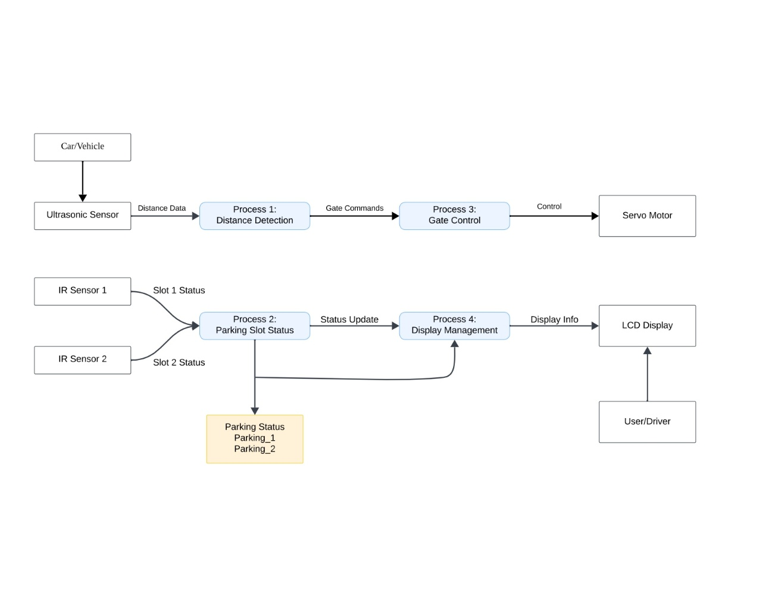**6.3 circuit diagram**

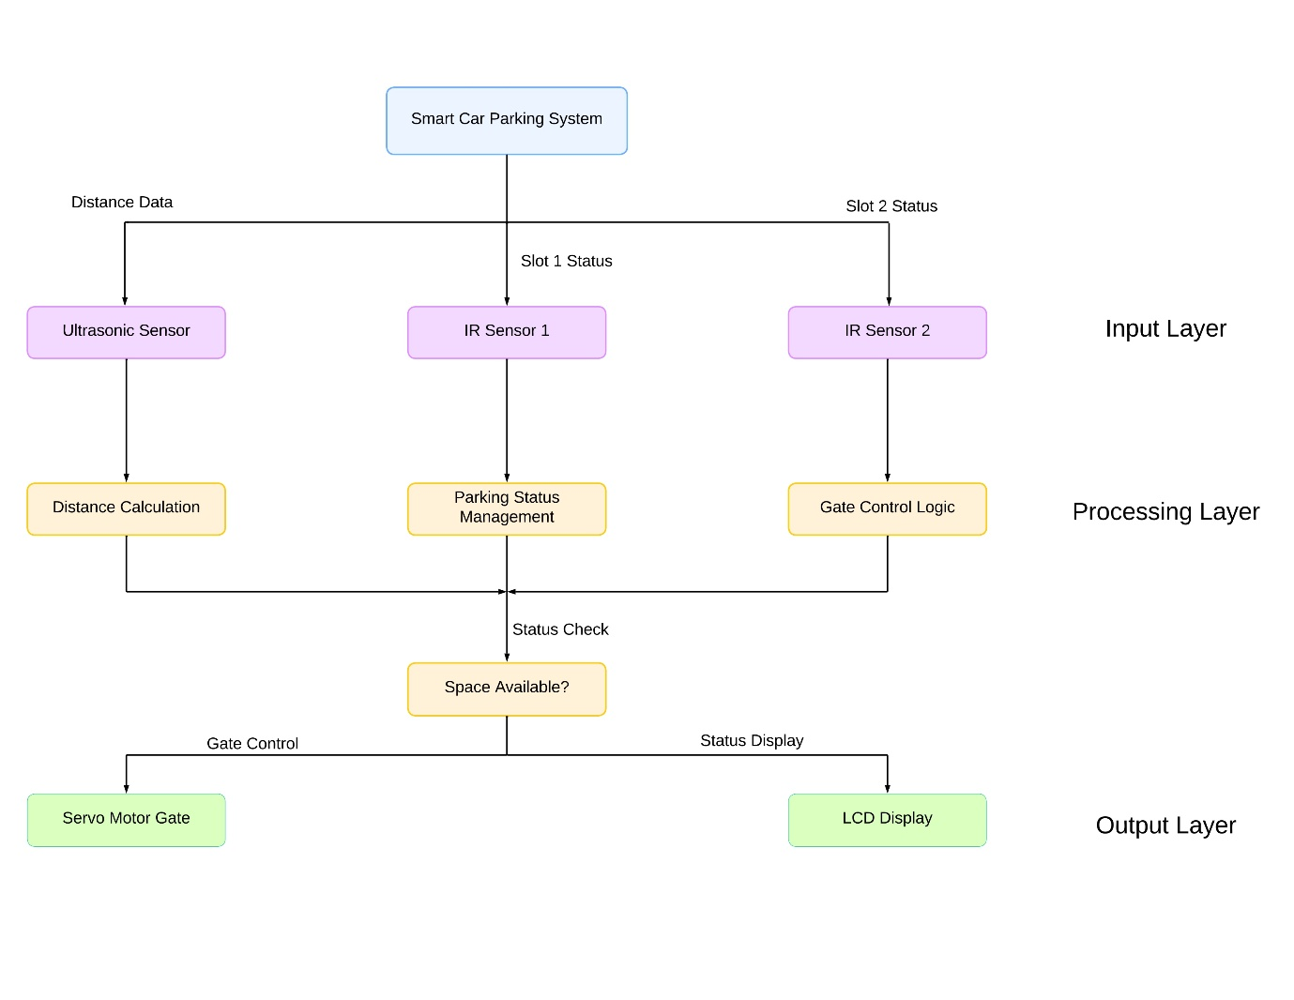

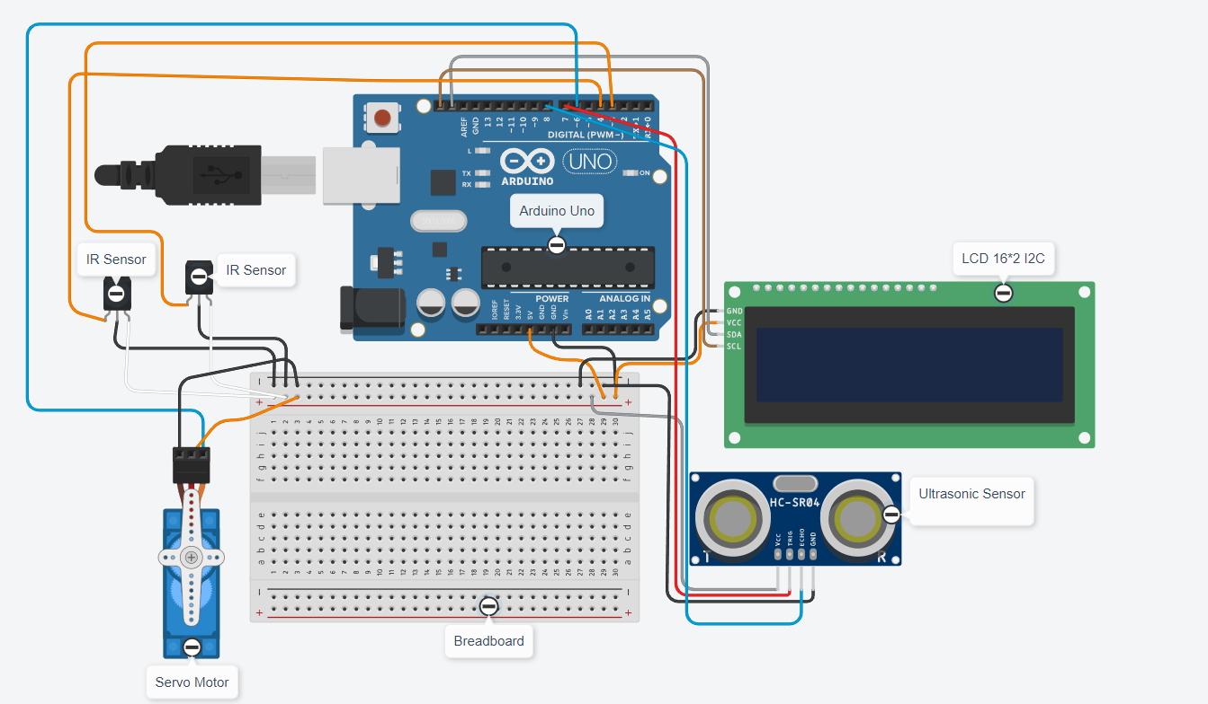

**CHAPTER 7**

**IOT MODULE**

* **Introduction to IOT Module**

The integration of the Internet of Things (IoT) into modern systems has dramatically enhanced the efficiency of various operations, and one prominent example is the IoT-based parking management system. This technology allows for the automation of parking space management by connecting physical devices such as sensors, controllers, and actuators to a centralized network for real-time monitoring and control. In the context of parking management, the IoT module is a crucial element that ensures smooth operation by automating the detection of available parking spaces and communicating this information to users and administrators.

The **IoT-based Parking Management System** involves the use of multiple sensors, including **ultrasonic and infrared (IR) sensors**, to detect the presence of vehicles in parking spaces. These sensors are connected to an **Arduino microcontroller**, which processes the data and sends the information to the cloud via a **Wi-Fi module (ESP8266)**. The real-time data is then displayed on a cloud-based dashboard, allowing users to check the availability of parking spaces from their mobile devices or computers. The system continuously updates the status of each parking spot, providing an intuitive and user-friendly interface for both drivers and parking lot managers.

The IoT module plays an essential role in ensuring that the parking system operates efficiently. It begins with **pre-processing steps**, where the raw sensor data is validated and cleaned to remove noise or erroneous readings. This ensures that the system operates based on accurate and reliable information. Once validated, the data is sent to a cloud-based platform where it is visualized in real-time. This **data visualization** process allows users to monitor parking space availability, enabling them to make informed decisions about where to park.

A key feature of the IoT module is its ability to facilitate **real-time communication** between the parking system and the cloud using MQTT (Message Queuing Telemetry Transport). This lightweight communication protocol ensures fast and reliable data transmission, allowing the system to update the parking space status promptly and without delay. Additionally, the **result analysis** of collected data can provide valuable insights into parking patterns, peak times, and the efficiency of space utilization, further optimizing the management process.

Overall, the IoT module in the parking management system significantly enhances user convenience, reduces the need for human intervention, and contributes to a more efficient use of available parking spaces. It transforms traditional parking systems into smart, automated solutions that are essential for modern urban environments and smart cities.

* 1. **Pre-processing Steps**
* **Data Collection**

Data collection is a critical initial step in the parking management system. Sensors installed in the parking lot continuously gather data that serves as the foundation for the entire system.

* + Ultrasonic sensors detect the presence of a car by sending out high-frequency sound waves. When these waves encounter an object (like a car), they bounce back to the sensor, and the time taken for the waves to return is used to calculate the distance. This measurement is then interpreted by the system to check whether a parking space is occupied.
  + The IR sensors, typically placed at the entrances and exits, monitor the movement of vehicles. When a vehicle passes through the sensor’s infrared beam, it disrupts the signal, alerting the system to the vehicle’s presence.
  + These sensors are essential for capturing real-time data about the parking lot. This information is crucial in maintaining accurate availability status on the MQTT dashboard, which is used to inform the users about parking space occupancy.
  + The Arduino Uno is responsible for gathering data from these sensors and performing the initial processing. It’s vital that the system reads this data frequently and accurately to ensure that parking availability is updated in real-time.
  + Once data is collected, it is then prepared for transmission to the MQTT broker. This is a continuous process, where sensor data is periodically checked and updated based on the sensor readings.
* **Noise Filtering**

Noise filtering plays a crucial role in maintaining the accuracy of the sensor data. Environmental conditions, sensor imperfections, and interference from nearby objects can affect sensor readings, leading to inaccuracies in the data.

* + For example, ultrasonic sensors can be affected by objects in the environment, such as walls or parked cars, which can cause erroneous readings. The algorithm needs to filter out these false readings to maintain accurate data.
  + Digital signal processing (DSP) techniques can be implemented to smooth out sudden spikes or drops in sensor data. This technique averages data points over time, ensuring that only the most reliable readings are used.
  + A threshold-based method can be used for noise filtering. If the sensor reading is beyond a specified threshold (either too high or too low), the reading is discarded as noise and does not contribute to the status update of the parking space.
  + The Arduino code incorporates error-detection algorithms that verify if the data collected from the sensors is consistent with the expected values. If any discrepancies are found, the erroneous data is rejected and does not affect the overall operation.
  + Additionally, Kalman filtering can be applied to smooth sensor data and eliminate jitter, leading to more stable measurements.
  + Once noise has been filtered out, the processed data is ready for further analysis or visualization, allowing the system to maintain an accurate representation of the parking lot’s occupancy.
* **Data Transformation & Aggregation**

After noise filtering, the data undergoes transformation into a useful format that can be used to make decisions regarding the status of each parking space.

* + The ultrasonic sensor provides continuous distance measurements, but these values need to be converted into a more intuitive binary format: occupied or vacant. If the distance is smaller than the predefined threshold (indicating a car is present), the parking space is marked as occupied. If the distance exceeds this threshold, the parking space is marked as vacant.
  + Similarly, data from the IR sensors is straightforward: a 1 indicates a vehicle has passed through the sensor’s beam, while a 0 means no vehicle is present.
  + The next step is data aggregation. This step combines the data from multiple sensors into a coherent status report. For example, if the IR sensor at the parking entrance detects a car, and the ultrasonic sensor confirms that the parking space is full, the data is aggregated to show that the parking lot has reached full capacity.
  + The data from various sensors are aggregated on the Arduino Uno, which calculates the overall status of the parking lot, including the availability of each individual parking space. This information is formatted into a message that can be sent to the MQTT broker for further transmission.
  + After aggregation, the system may use algorithms to predict parking space availability for the next few hours or detect patterns based on historical data. This step allows the system to provide more informed insights to users about peak parking hours.
  + The transformed and aggregated data is then transmitted via the ESP8266 Wi-Fi module, ensuring seamless communication with the cloud platform for real-time monitoring.

**7.2 Data Visualization**

* **Dashboard Overview**

The **cloud-based dashboard** is the user-facing interface that visualizes parking lot occupancy in real-time. It provides users with a clear and concise view of available and occupied parking spaces.

* + The dashboard displays the **parking lot layout** in a graphical format, where each parking space is represented by an icon that changes color based on its status: green for available and red for occupied.
  + The layout may also include **zoomable maps**, allowing users to view a specific section of the parking lot if it's large. This feature enables users to navigate through the parking lot visually and make better parking decisions.
  + The **MQTT protocol** ensures that data sent from the sensors to the cloud is published and updated on the dashboard with minimal latency. The dashboard interface communicates with the MQTT broker, allowing it to dynamically receive and display the real-time status of each parking spot.
  + Users can interact with the dashboard, clicking on individual parking spaces for detailed information. For example, users might click on a specific spot to see when it was last occupied or to view usage statistics over time.
  + In addition to real-time updates, the dashboard may also display the **occupancy rate** of the parking lot, helping users understand the overall parking situation, including how many spaces are currently available and the likelihood of finding an empty spot.
* **Real-Time Updates**

The **real-time update feature** is one of the most critical aspects of the dashboard. It ensures that users have access to up-to-date information regarding parking availability without needing to refresh or reload the page.

* + When the **Arduino Uno** receives updated data from the sensors, it sends the information via the **ESP8266 module** to the MQTT broker, which in turn pushes the data to the dashboard.
  + The **MQTT broker** is responsible for handling the message queuing process. It ensures that messages are delivered in a timely and reliable manner, ensuring that the dashboard always displays the correct parking space status.
  + The real-time feature minimizes waiting times for users, as they can make quick decisions based on the current availability of parking spaces. This also reduces the time spent searching for parking, which is a common frustration for drivers in crowded lots.
  + The dashboard automatically refreshes the status of each parking space at regular intervals or when new data is received, ensuring that the information is always accurate.
  + If a parking spot becomes available (e.g., when a car leaves), the system instantly updates the dashboard, making the space available for another user to park. This continuous loop of data communication ensures that the parking management system operates smoothly.
* **User Interface and Accessibility**

The **user interface (UI)** of the dashboard is designed with ease of use in mind. It is intuitive, clean, and user-friendly, ensuring that all users—whether tech-savvy or not—can navigate and use the dashboard effectively.

* + Key UI elements include **color-coded icons**, buttons for real-time refresh, and clickable parking spaces that provide more detailed information. Each parking space can be color-coded based on its status, such as green for available, red for occupied, or yellow for pending (e.g., when a car is moving in or out).
  + The dashboard is optimized for different **devices**, including desktops, tablets, and smartphones. This makes it accessible to a wide range of users, ensuring that people on the go or in the parking lot itself can easily check parking availability.
  + In addition to basic functionality, the dashboard also features **search filters** or sorting options, allowing users to find available parking spaces based on criteria like proximity to the entrance or their current location.
  + Accessibility features include **high contrast modes**, larger text options, and voice commands for people with disabilities, making the system inclusive and usable for a broader audience.
  + The interface also supports **multi-language options**, allowing people who speak different languages to access and navigate the system without barriers.
  + The real-time nature of the updates means that users do not need to manually refresh the page—data updates automatically, keeping users informed without additional effort.

**7.3 IoT Model Description**

The integration of the IoT module allows for efficient real-time decision-making by parking system administrators and users. By automating the process of detecting available parking spaces and managing the entrance and exit of vehicles, the system minimizes human error and reduces operational overhead. As a result, it can handle large volumes of cars in busy urban areas while maintaining an organized and streamlined operation.

The real-time monitoring aspect provided by the IoT system is one of its most significant benefits. Since the data is sent to the cloud, it is accessible from anywhere and at any time, using mobile apps or web dashboards. This not only helps drivers find available parking more easily, but also assists parking lot operators in tracking space usage, optimizing parking lot design, and managing traffic flow efficiently.

Another significant aspect of the IoT-based parking system is its scalability. As cities grow and parking demand increases, the system can easily accommodate additional sensors or parking spots without requiring a major overhaul. The modular design ensures that parking spaces can be added incrementally, making it suitable for both small parking areas and large multi-level parking structures.

The sustainability of the IoT system is another key benefit. By reducing the amount of time drivers spend searching for parking spaces, the system helps lower fuel consumption and emissions. In addition, it optimizes the usage of parking spaces, ensuring that no space is underutilized and that the entire parking lot is used as efficiently as possible.

Furthermore, the integration of security features within the IoT module ensures that only authorized users can access parking spaces. By leveraging technologies like RFID tags, license plate recognition, or user authentication through mobile apps, the system adds an extra layer of security to prevent unauthorized parking and improve the overall safety of the facility.

In summary, the IoT module within a parking management system provides not just convenience but also significant operational advantages. By automating data collection, processing, and transmission, it ensures smooth and efficient parking lot management, allowing for smarter cities and better experiences for both users and operators. This technological framework sets the stage for further innovation and optimization, positioning IoT-based parking systems as a cornerstone of modern urban infrastructure.

**7.4 Result Analysis of IoT-based Parking Management System**

The **result analysis** of the IoT-based parking system is a crucial aspect that enables ongoing optimization and ensures that the system performs effectively. Once data is collected from the various sensors, processed, and visualized in real-time, it is analysed to evaluate the system’s overall performance and identify areas for improvement. The system's effectiveness is not only measured by its ability to provide real-time parking space availability but also by its efficiency in space utilization, its accuracy in sensor readings, and the quality of its communication protocols.

By analysing the sensor data, such as the occupancy patterns of parking spaces, peak usage times, and vehicle entry/exit trends, valuable insights can be derived. These insights can help in improving the management of parking facilities by enabling administrators to predict high-demand periods and take proactive actions to manage traffic flow. For instance, if the analysis reveals that certain parking spaces are consistently underutilized, the system can be reconfigured to ensure that the parking layout is optimized for better utilization.

Furthermore, result analysis can help in improving the user experience. By continuously analysing parking trends, the system can make suggestions for available spots based on historical data, reducing the amount of time users spend searching for a space. This data-driven approach allows for a more streamlined and efficient parking experience for drivers, leading to better overall satisfaction.

The results can also be used to track the performance of different components of the system, such as the accuracy of the sensors, speed of data transmission, and dashboard responsivene**ss**. If any component is underperforming, the system can trigger maintenance alerts or suggest adjustments to improve performance. For example, if the ultrasonic sensor readings are found to be inconsistent, recalibration might be necessary, or the system could use a combination of multiple sensors to improve reliability.

Additionally, traffic analysis from the data can highlight bottlenecks or congested areas in the parking lot, helping managers reconfigure entry and exit points or modify the layout for better traffic flow. This helps avoid gridlocks and reduces the time it takes for users to enter and exit the parking lot.

Result analysis also plays a key role in long-term system improvement. As the system continuously collects and processes data, it becomes more intelligent over time, allowing it to make better predictions about parking space availability and optimize parking lot operations. The system can learn from past trends and adjust to evolving parking behaviours, ensuring that it remains efficient and responsive to users' needs.

In conclusion, the result analysis in an IoT-based parking management system is not just about tracking current performance; it’s also about continuously refining the system to make it more efficient, user-friendly, and responsive to the changing dynamics of parking management. The insights gathered from result analysis are instrumental in ensuring the system’s sustained success and its adaptability to future demands.

**CHAPTER 8**

**CODING**

#include <LiquidCrystal_I2C.h>

#include <Servo.h>

// LCD and Servo configurations

LiquidCrystal_I2C lcd(0x27, 20, 4); // set the LCD address for a 16 chars and 2-line display

Servo myservo; // create servo object to control a servo

// Pin definitions

const int IR_PIN_1 = 4;

const int IR_PIN_2 = 5;

const int servo_pin = 6;

const int trigPin = 7;

const int echoPin = 8;

// Variables

int distance;

int pos = 0; // variable to store the servo position

int IT_State_1;

int IT_State_2;

String Parking_1;

String Parking_2;

void setup() {

pinMode(trigPin, OUTPUT);

pinMode(echoPin, INPUT);

pinMode(IR_PIN_1, INPUT);

pinMode(IR_PIN_2, INPUT);

Serial.begin(9600); // Initialize serial communication

lcd.init();

lcd.backlight();

// Servo calibration

lcd.clear();

lcd.setCursor(0, 0);

lcd.print("Motor Calibration");

lcd.setCursor(0, 1);

lcd.print("started");

delay(1000);

myservo.attach(servo_pin);

for (pos = 15; pos <= 160; pos += 1) {

myservo.write(pos);

delay(15);

}

for (pos = 160; pos >= 13; pos -= 1) {

myservo.write(pos);

delay(15);

}

myservo.detach();

lcd.clear();

lcd.setCursor(0, 0);

lcd.print("Motor Calibration");

lcd.setCursor(0, 1);

lcd.print("Done");

delay(1000);

lcd.clear();

lcd.setCursor(0, 0);

lcd.print("Car");

lcd.setCursor(0, 1);

lcd.print("Parking System");

delay(2000);

}

void loop() {

distance = ultra();

// Check if parking space is available

if ((distance < 10) && ((Parking_1 == "EMPTY") || (Parking_2 == "EMPTY"))) {

myservo.attach(servo_pin);

for (pos = 5; pos <= 160; pos += 1) {

myservo.write(pos);

delay(15);

}

for (pos = 160; pos >= 5; pos -= 1) {

myservo.write(pos);

delay(15);

}

myservo.detach();

}

// Read IR sensors to determine slot occupancy

IT_State_1 = digitalRead(IR_PIN_1);

Parking_1 = (IT_State_1 == LOW) ? "FULL" : "EMPTY";

IT_State_2 = digitalRead(IR_PIN_2);

Parking_2 = (IT_State_2 == LOW) ? "FULL" : "EMPTY";

// Update LCD display with parking slot statuses

lcd.clear();

lcd.setCursor(0, 0);

lcd.print("Slot One =" + Parking_1);

lcd.setCursor(0, 1);

lcd.print("Slot Two =" + Parking_2);

delay(1000);

}

// Function to get distance from ultrasonic sensor

int ultra() {

int result = 0;

unsigned long duration, distanceSum = 0;

for (int i = 0; i < 3; i++) {

digitalWrite(trigPin, LOW);

delayMicroseconds(2);

digitalWrite(trigPin, HIGH);

delayMicroseconds(10);

digitalWrite(trigPin, LOW);

duration = pulseIn(echoPin, HIGH);

distanceSum += duration / 58.2;

delay(10);

}

result = distanceSum / 3;

return result;

}

**CHAPTER 9**

**RESULT AND OUTPUT SCREENS**

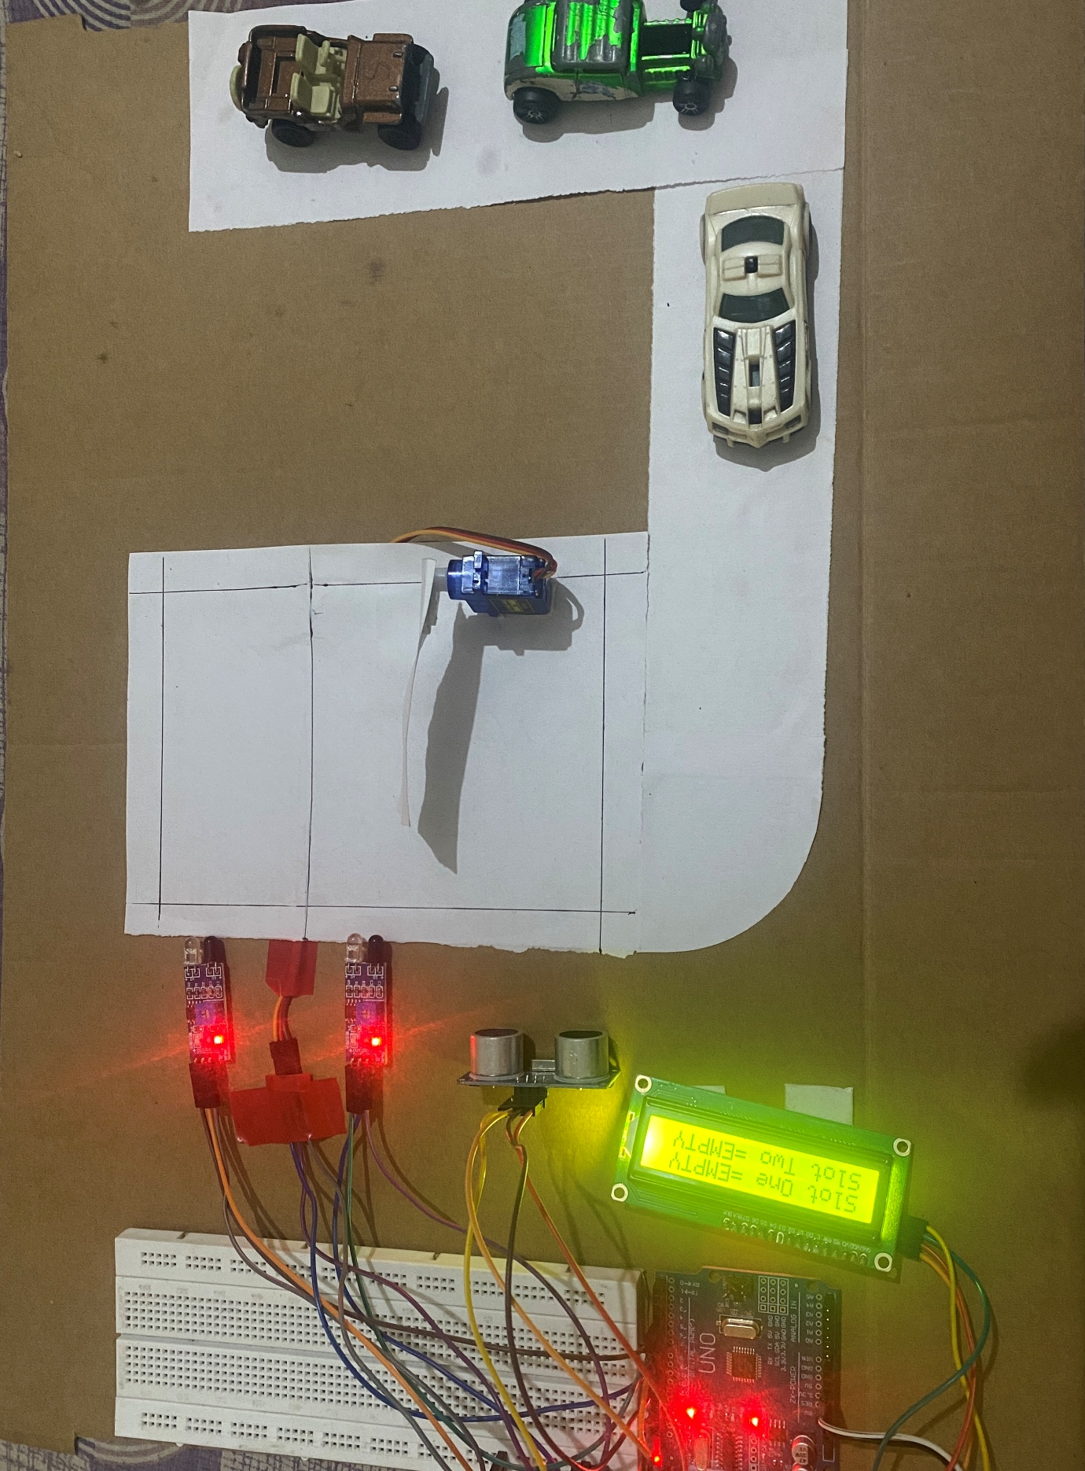

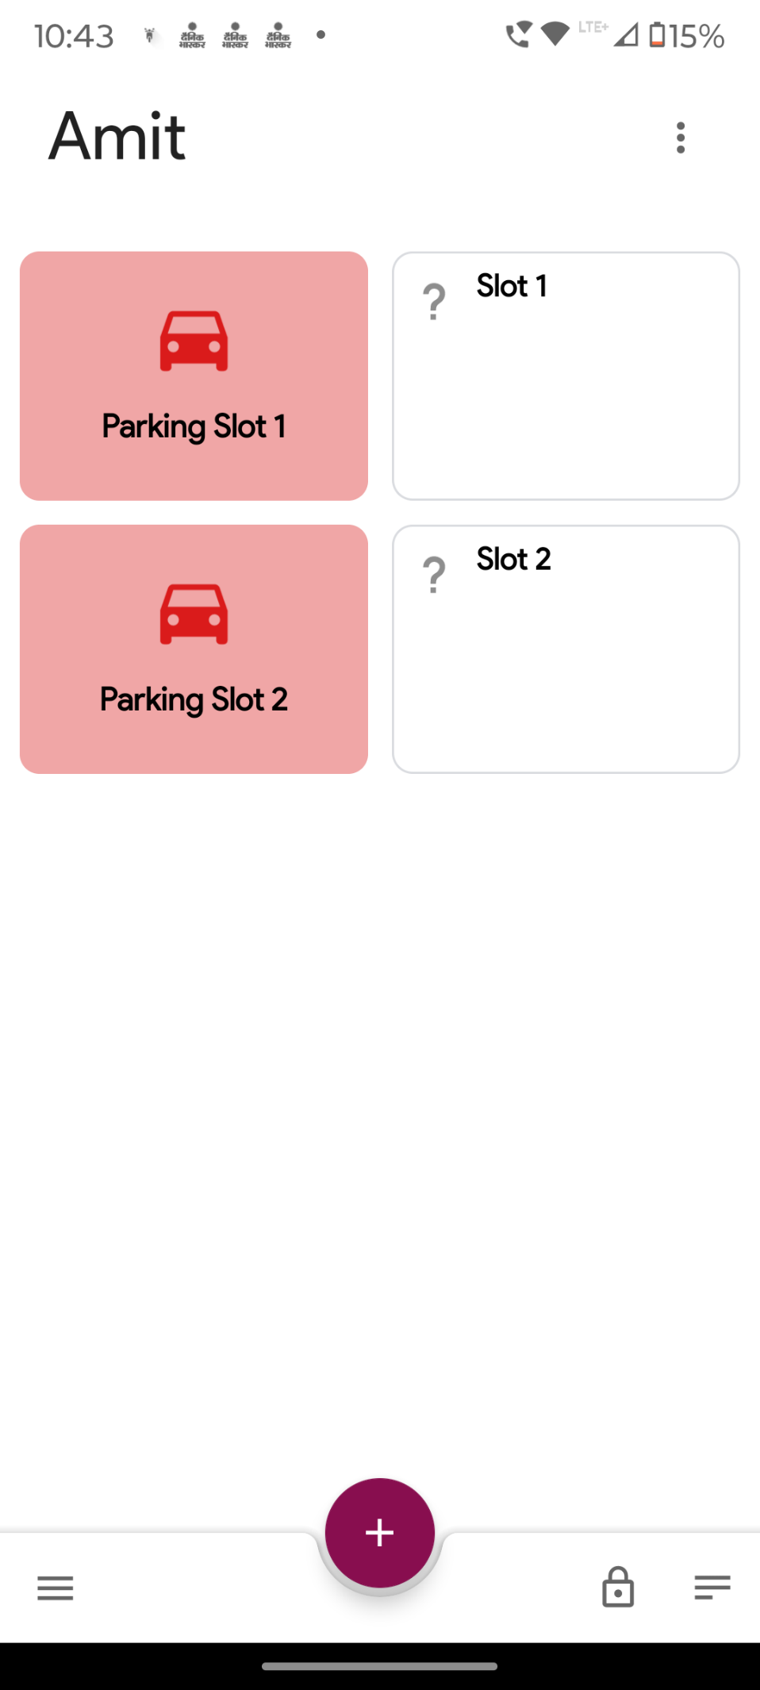

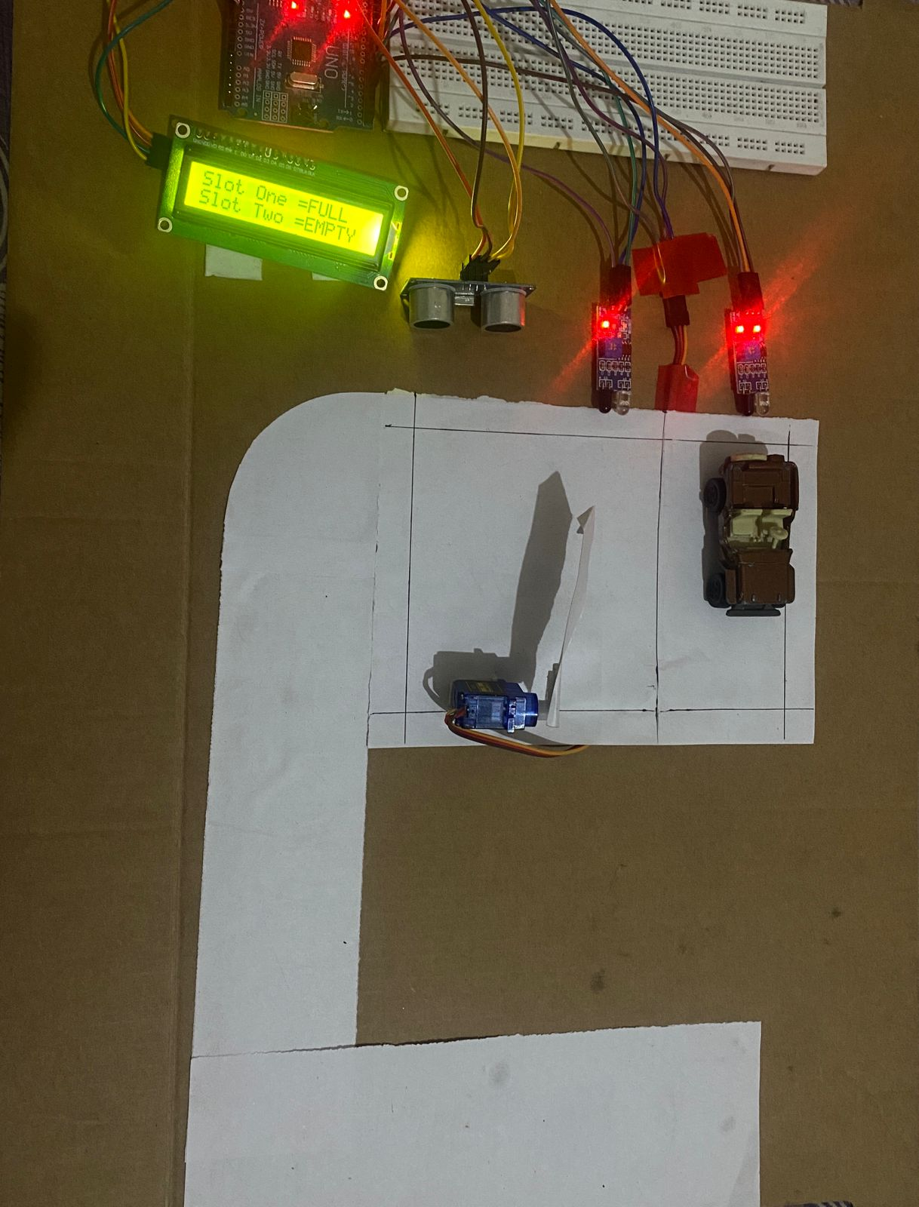

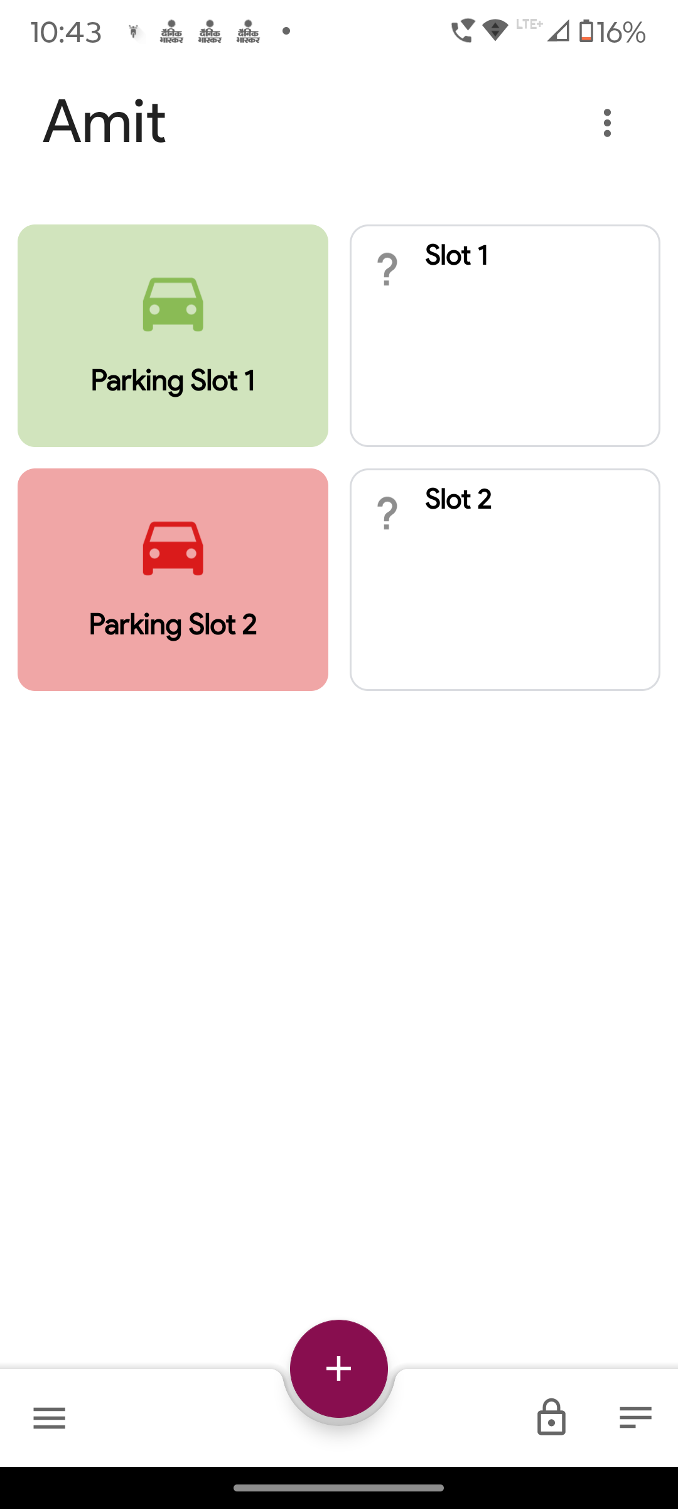

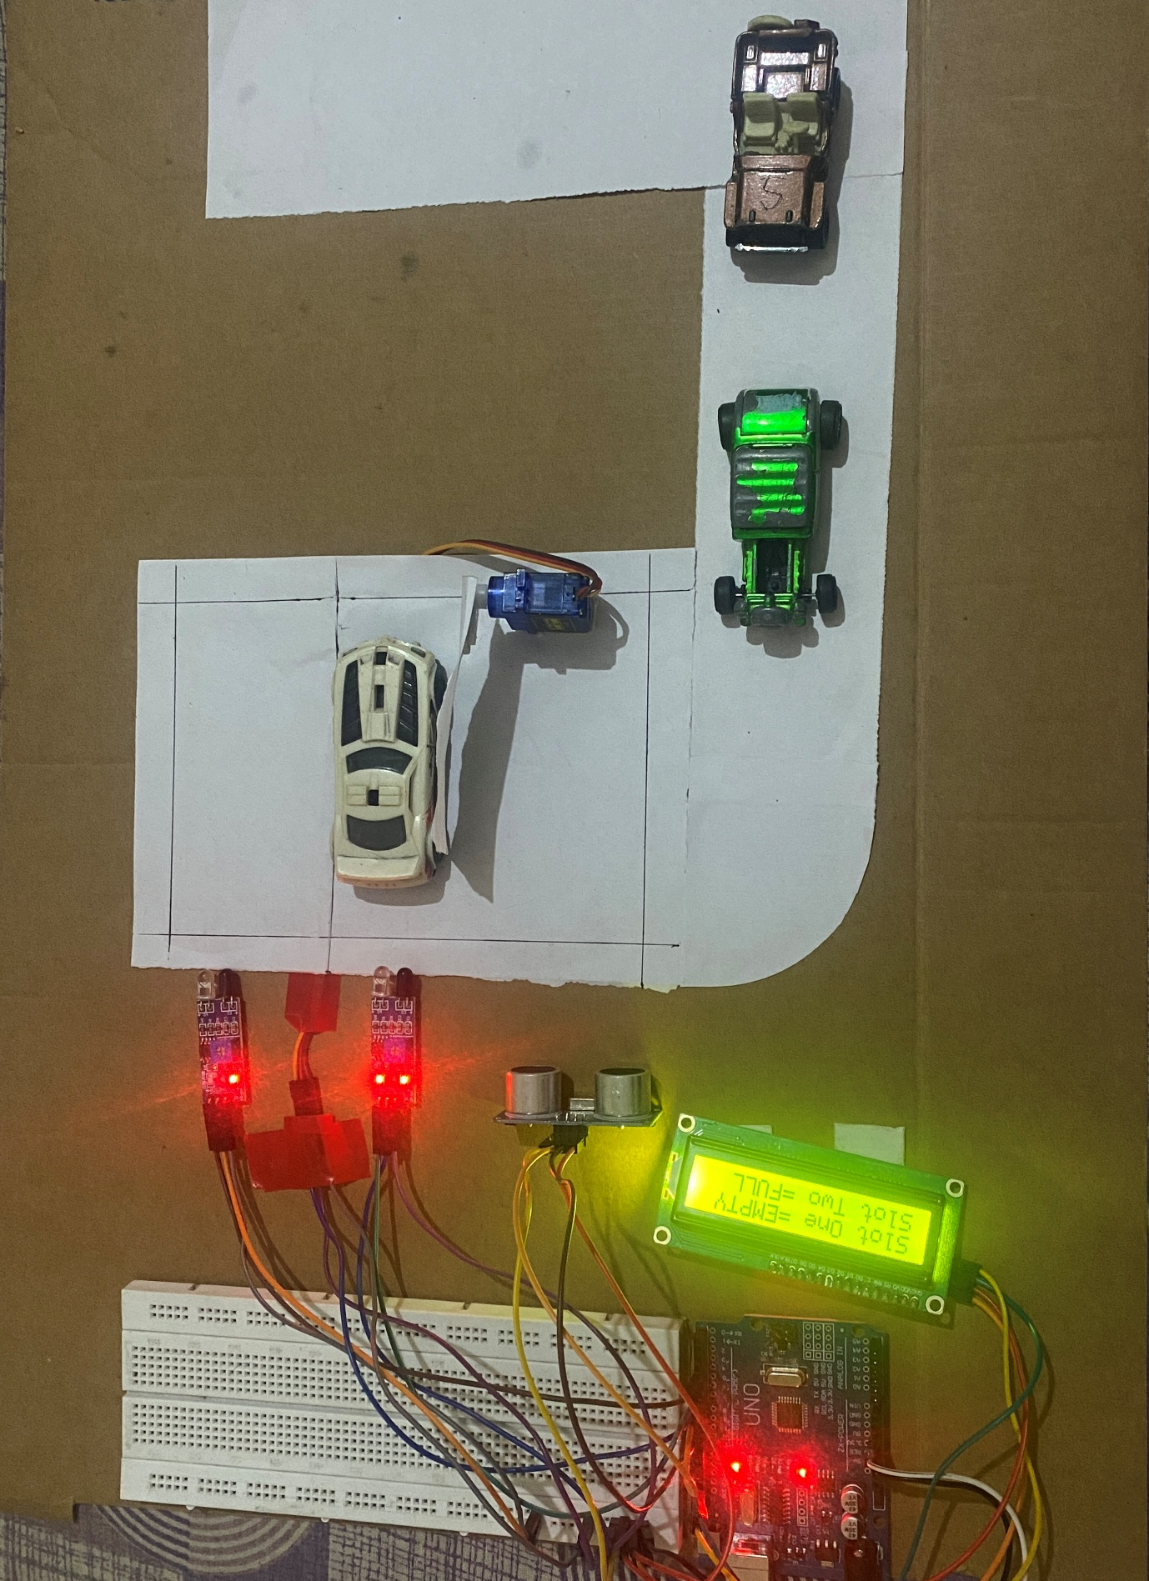

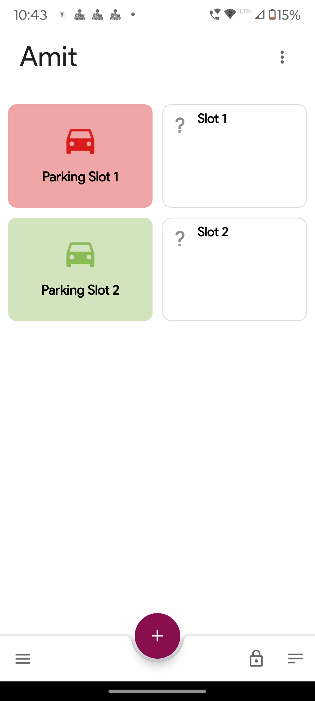

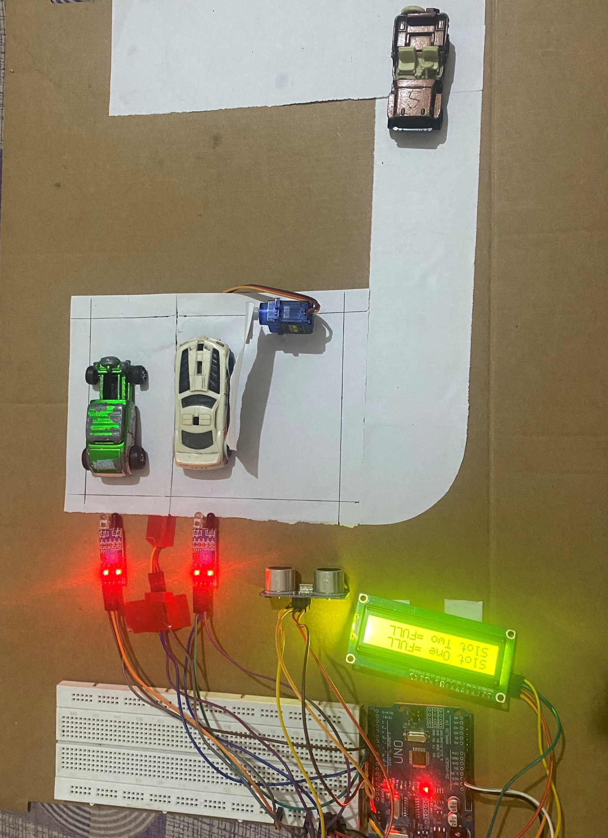

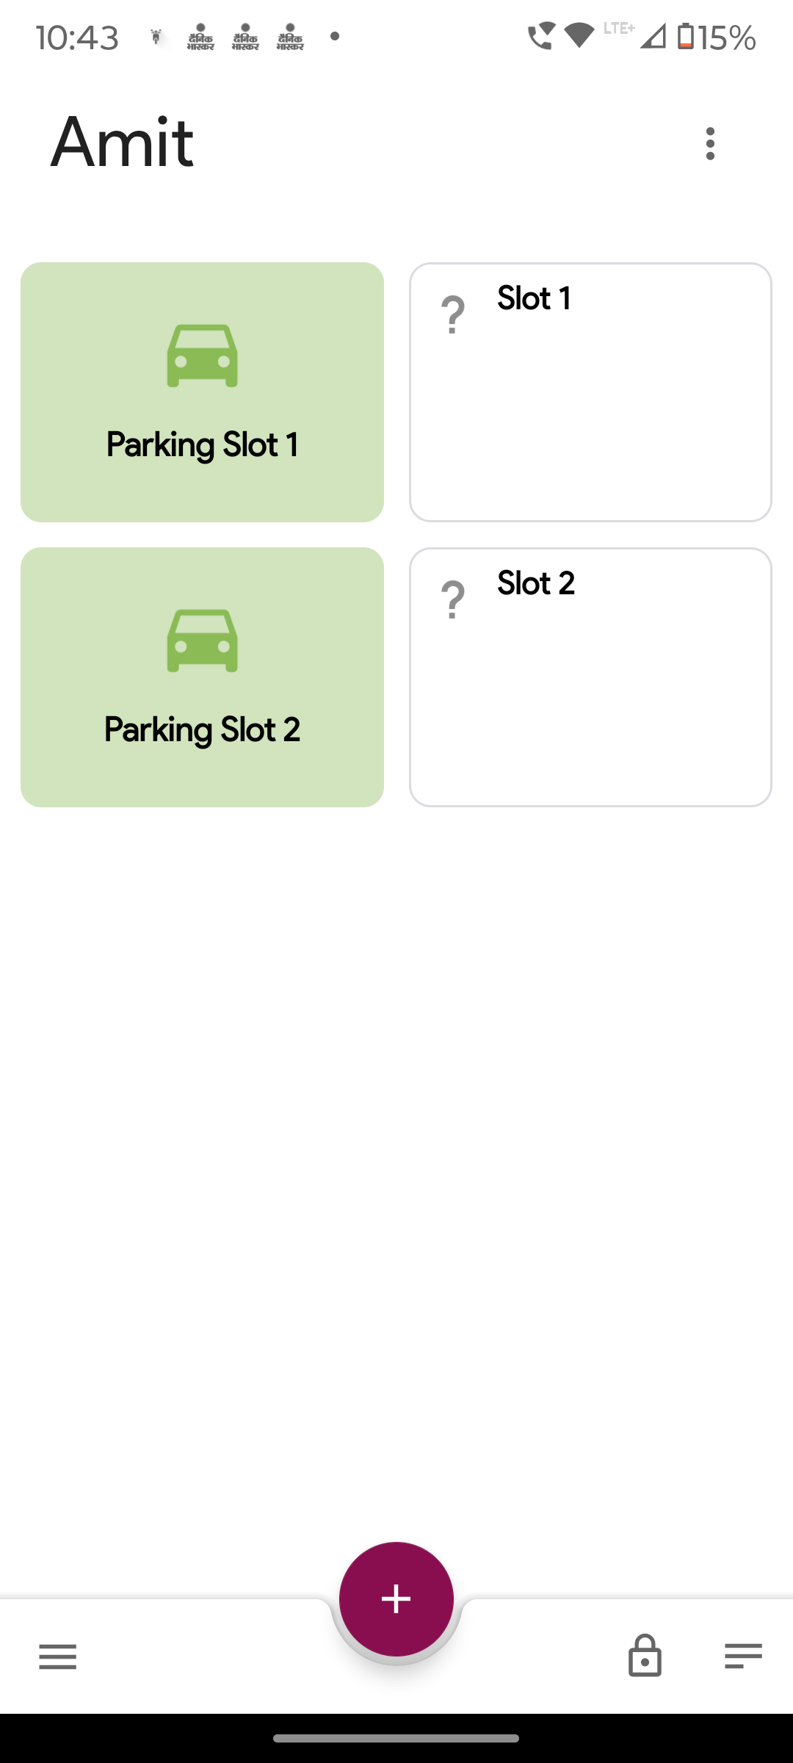

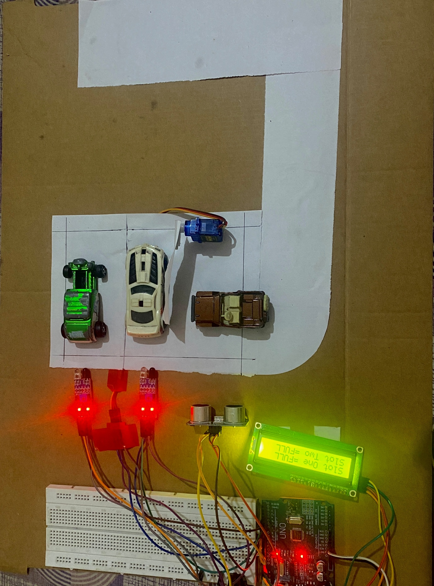



**CHAPTER 10**

**CONCLUSION AND FUTURE WORK**

* **Conclusion**

Our project detects the empty slots and helps the drivers to find parking space in unfamiliar city. The average waiting time of users for parking their vehicles is effectively reduced in this system. The optimal solution is provided by the proposed system, where most of the vehicles find a free parking space successfully. Our preliminary test results show that the performance of the Arduino UNO based system can effectively satisfy the needs and requirements of existing car parking hassles thereby minimizing the time consumed to find vacant parking lot and real time information rendering. This smart parking system provides better performance, low cost and efficient large scale parking system. When car enters the parking area, the driver will park the car in the nearest empty slot when slot is occupied the LED light glows and when slot is empty LED lights are turned off chromatically indicating that the parking slot is empty to be occupied. It also eliminates unnecessary travelling of vehicles across the filled parking slots in a city. Smart Parking solutions are designed to provide drivers an ultimate solution on their journey from the beginning to end without searching for parking, cost, travel time etc. This advantage comes by paying marginal fees to the smart parking service providers. To change a culture which has been existing for several centuries is a humongous task. Parking has always been an at the moment affair with direct cash exchange. The inclusion of technology in this method is a change in culture which will take the time to establish. Smart Parking is one of the most adopted and fastest growing smart city solutions across the world. Airports, universities, shopping centers and city garages are just a few entities that have begun to realize the significant benefits of automated parking technology.

In this study, the various types of smart parking system and has been presented. From the various examples of the implementation of the smart parking system being presented, its efficiency in alleviating the traffic problem that arises especially in the city area where traffic congestion and the insufficient parking spaces are undeniable. It does so by directing patrons and optimizing the use of parking spaces. With the study on all the sensor technologies used in detecting vehicles, which are one of the most crucial parts of the smart parking system, the pros and cons of each sensor technologies can be analyzed. Although, there are certain disadvantages in the implementation of visual based system in vehicle detection as described earlier, the advantages far outweigh its disadvantages.

* **Future Work**

In some of the parking areas are lacking such facilities and hence fail all the security norms necessary to park a vehicle. By looking such a huge concern, it is highly required that each and every parking area should be well equipped with high tech parking control systems, that nevertheless lasts the best. These innovative parking control systems not only make a bright choice but also allow you to pay the right price without getting any worry. parking control system has been generated in such a way that it is filled with many secure devices such as barricades, swing gates, slide gates, parking control gates, toll gates, time and attendance machine, car counting system etc. These features are hereby very necessary nowadays to secure your car and also to evaluate the fee structure for every vehicle’s entry and exit. Nowadays parking is very important and hence it is necessary for every vehicle owner to park his or her car in a secure designated parking slot available. To escalate this particular system various parking owners have integrated themselves with sophisticated parking control systems, which are high tech and offers full-fledged parking services.